Plugging into the future: An Exploration of Electricity Consumption Patterns
1. INTRODUCTION:

1.1 Overview
Electricity consumption represents the amount of electrical energy that has been consumed over a specific time. Consumption pattern of energy shows the percentage use of different sources (solar energy, wind energy, geothermal energy, biogas, and tidal power). The consumption pattern of energy changes over time. Commercial sources of energy: Commercial energy makes up about 65% of the total energy consumed in India.

1.2 Purpose
The purpose of electricity is to provide a reliable and efficient source of energy to power modern society. Electricity is a form of energy that is generated from various sources, such as fossil fuels, nuclear power, hydroelectric power, wind power, solar power, and others.
The primary purpose of electricity is to power homes, businesses, industries, transportation, and communication. It provides light, heat, and cooling, runs appliances and electronics, powers factories and assembly lines, supports transportation systems, and enables communication technologies.
Electricity has become an essential component of modern life and plays a crucial role in supporting economic and social development. It has revolutionized the way we live, work, and communicate, and it has contributed to many technological advancements that have improved the quality of life for people around the world.
Electricity has significant environmental implications, and its production and consumption have a significant impact on the environment. Therefore, the purpose of electricity also includes the need to generate and use it in a sustainable and responsible manner, minimizing its impact on the environment while meeting our energy needs.

2. Problem Definition & Design Thinking

EMPATHY MAP

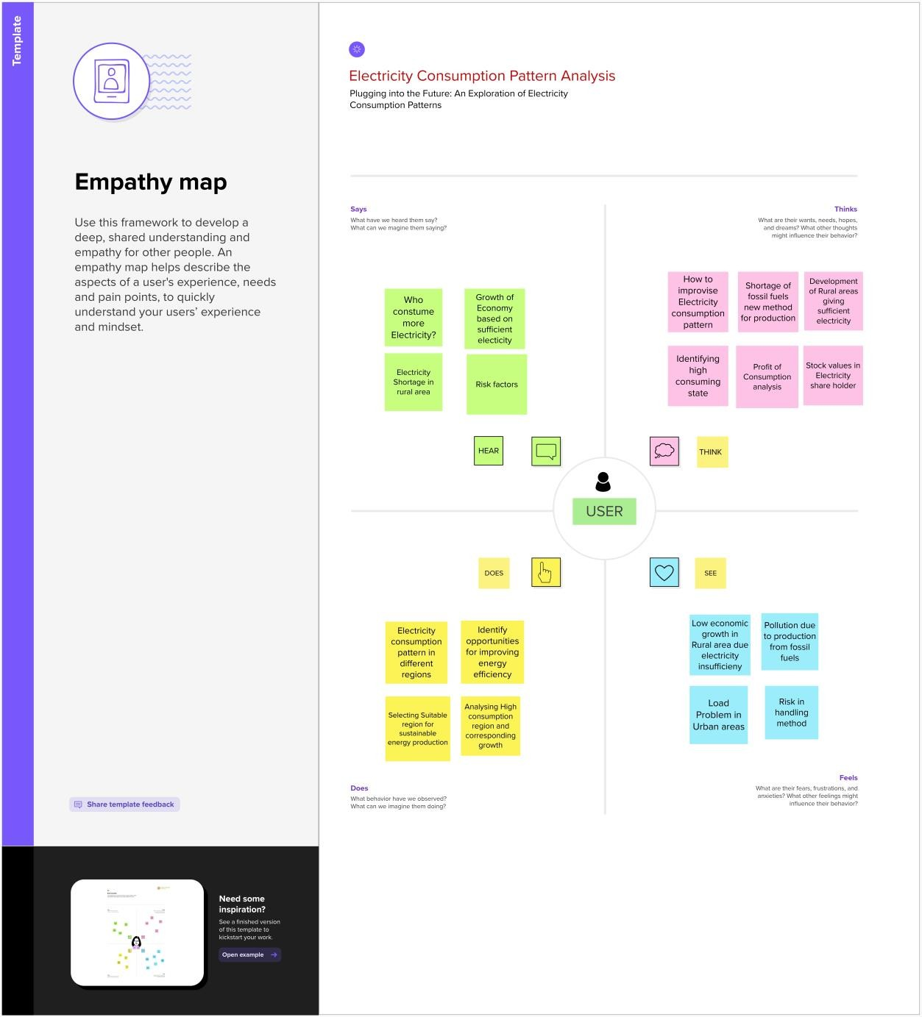

Ideation & Brainstorming Map
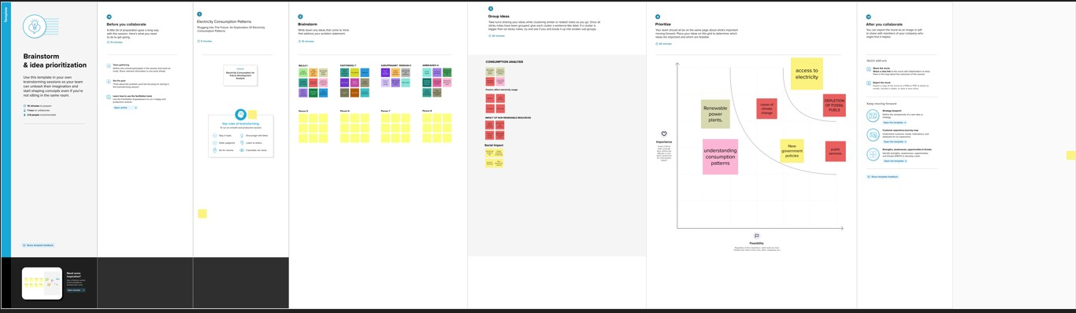

3. Result

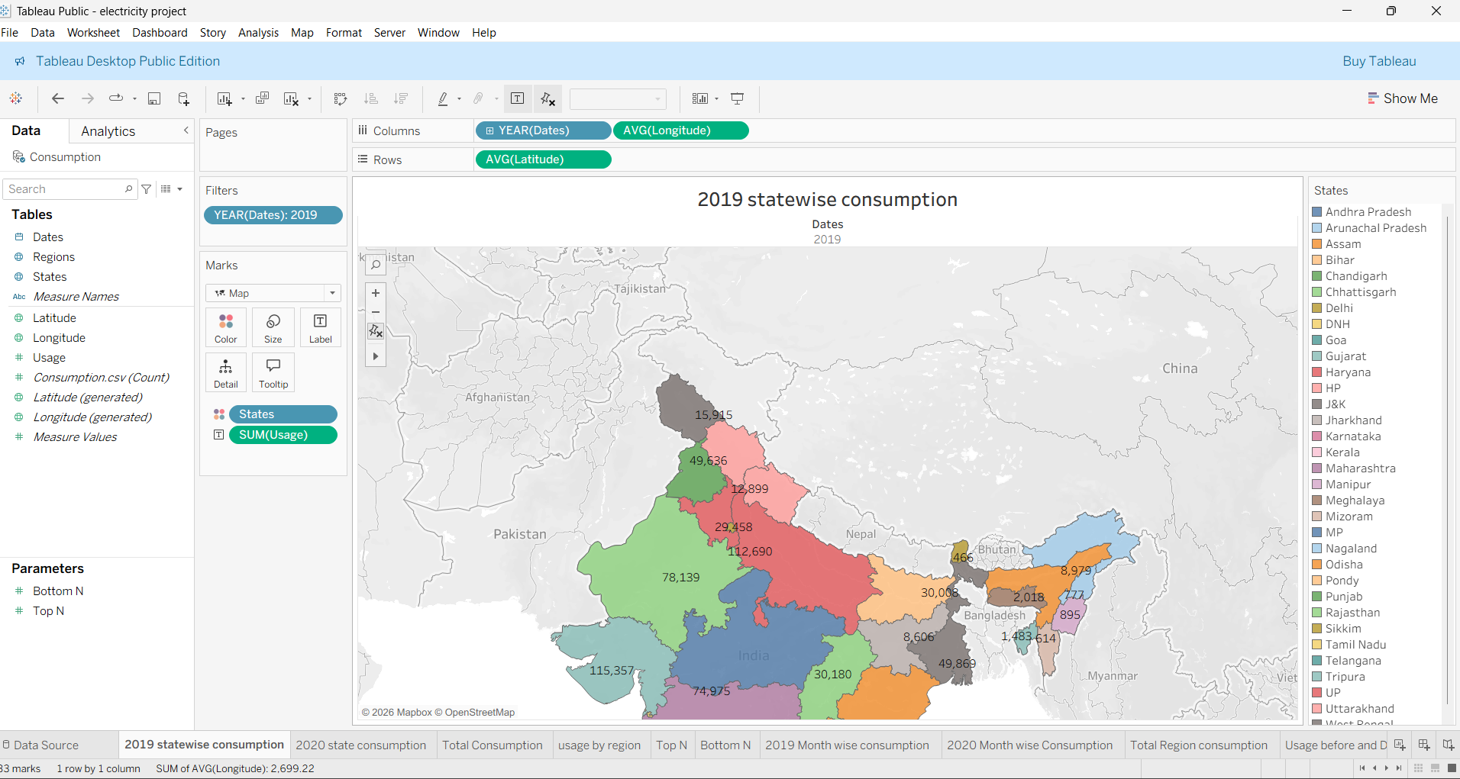
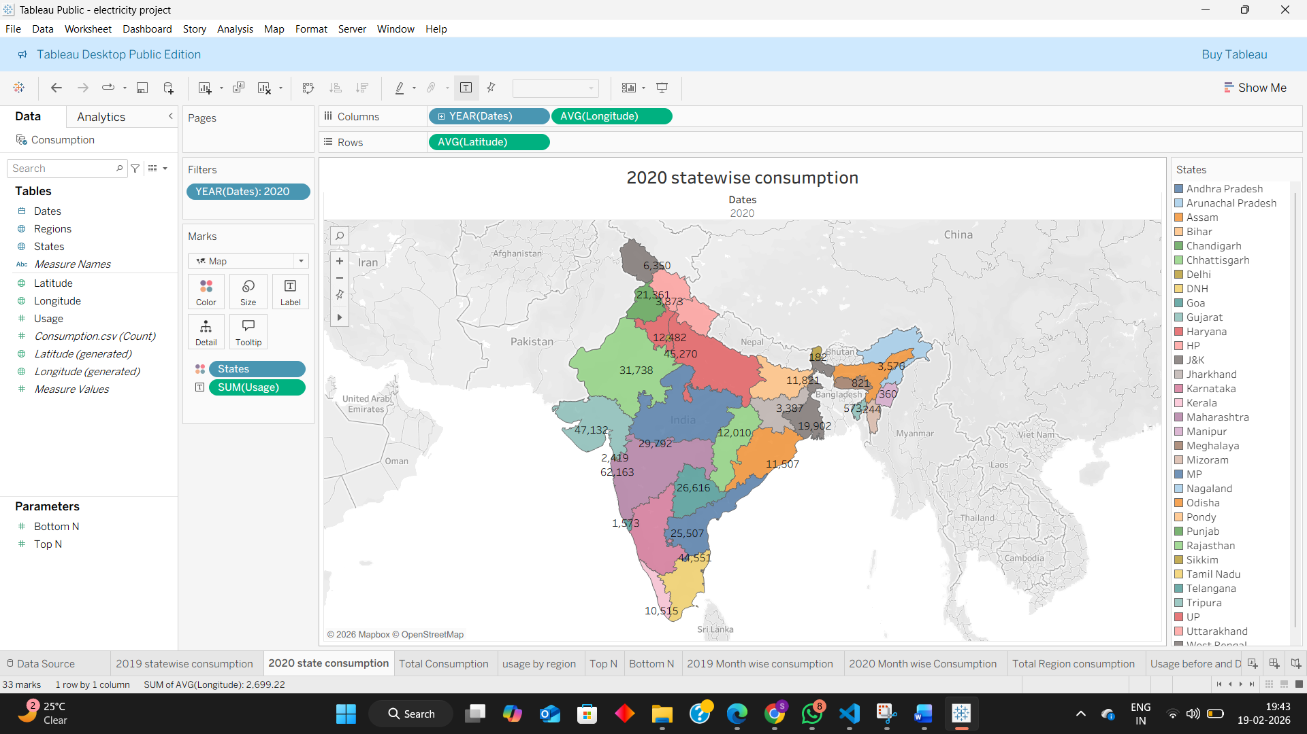

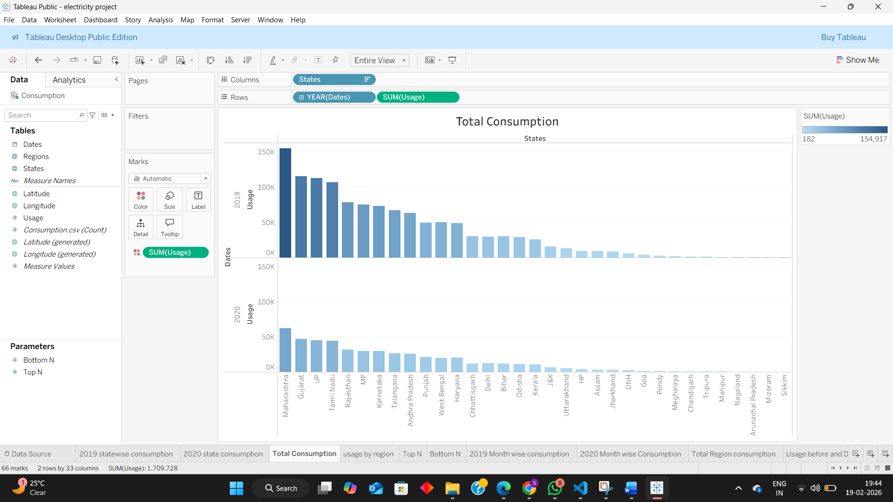
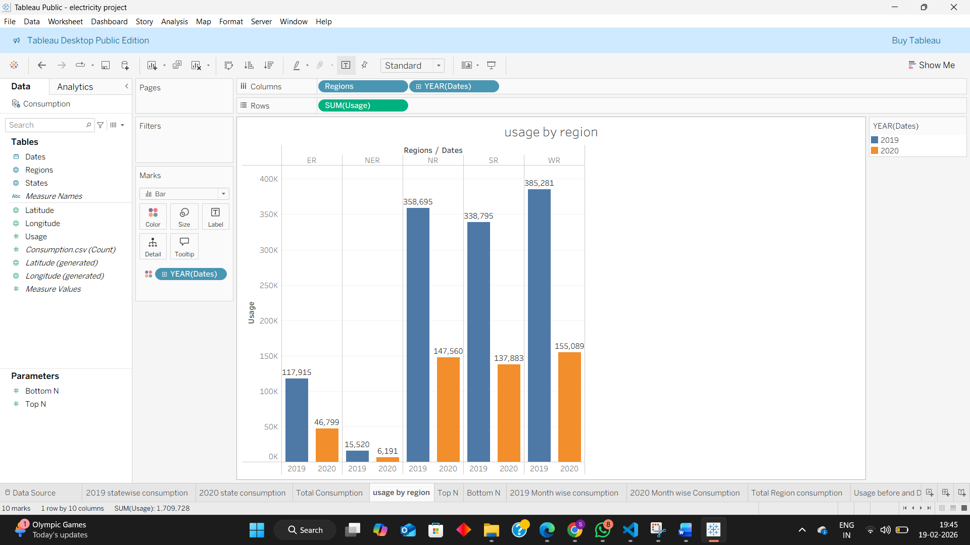
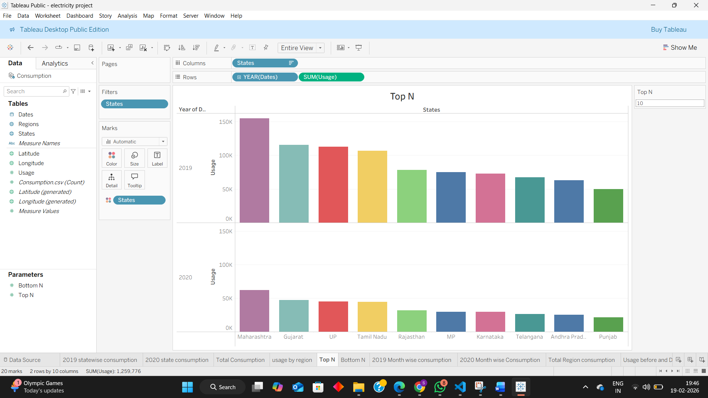
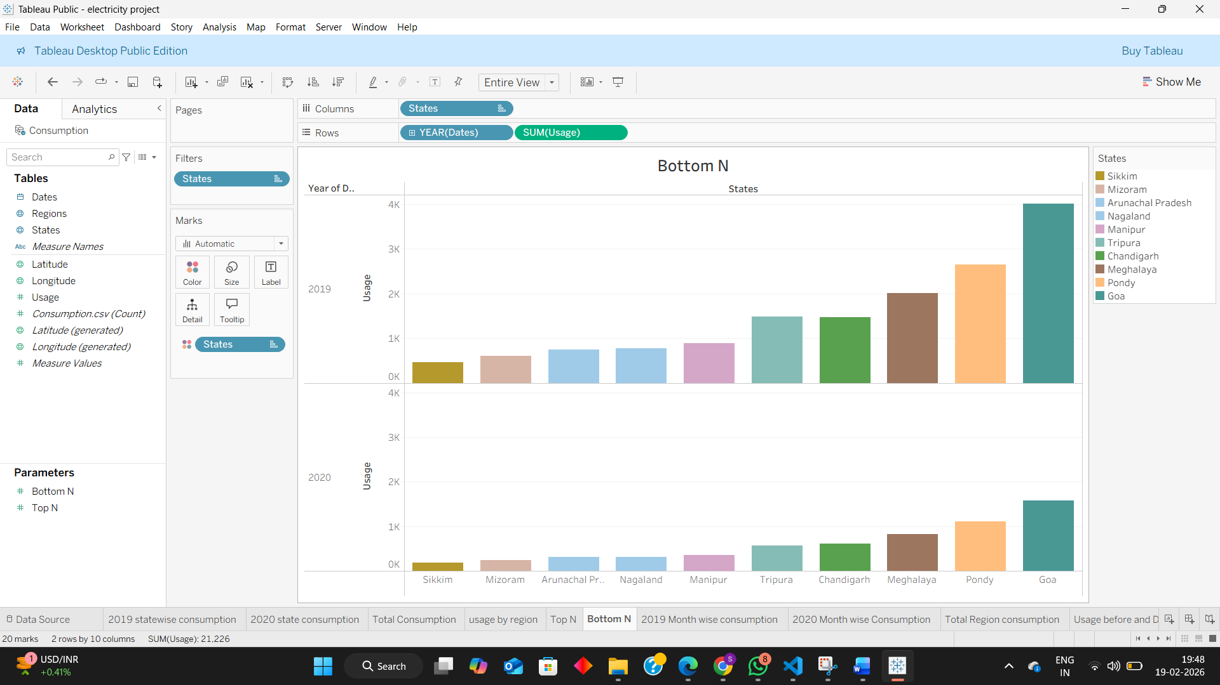

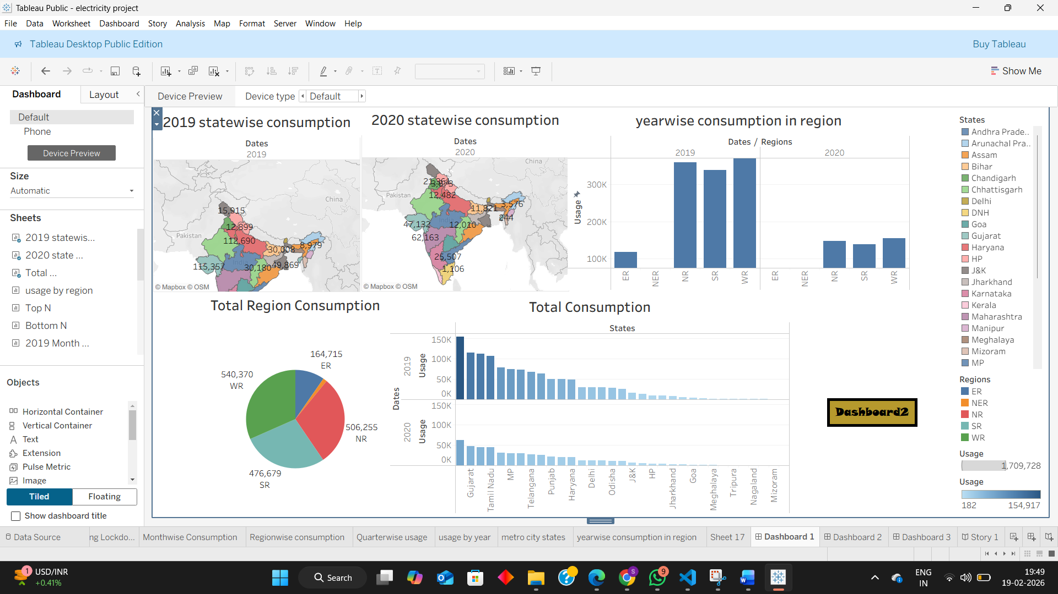

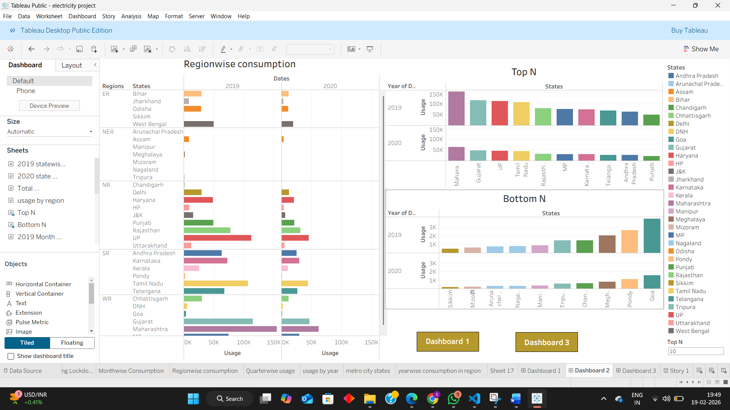
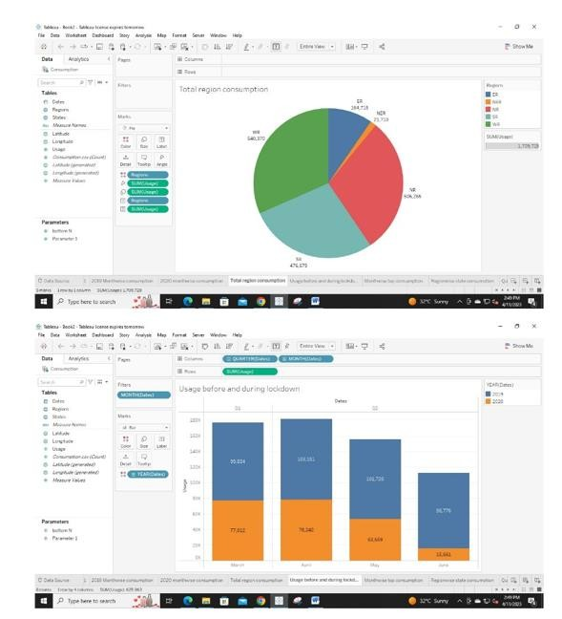

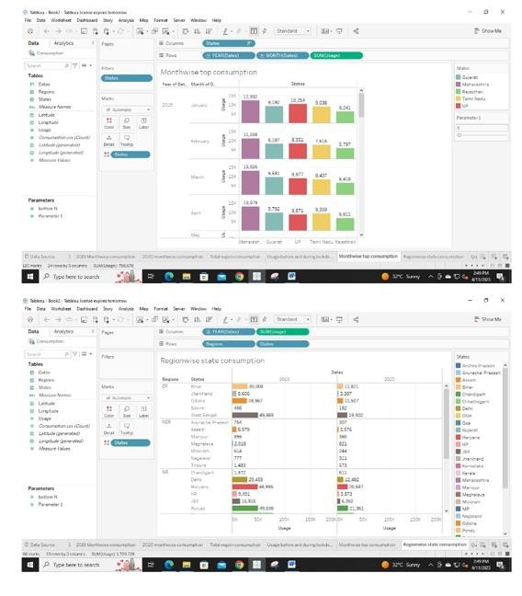
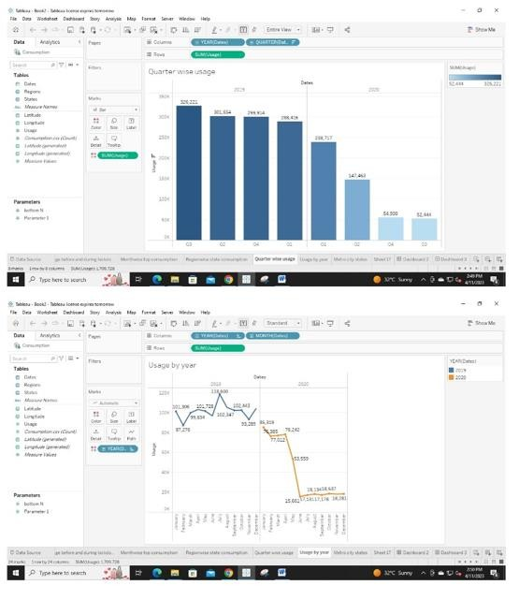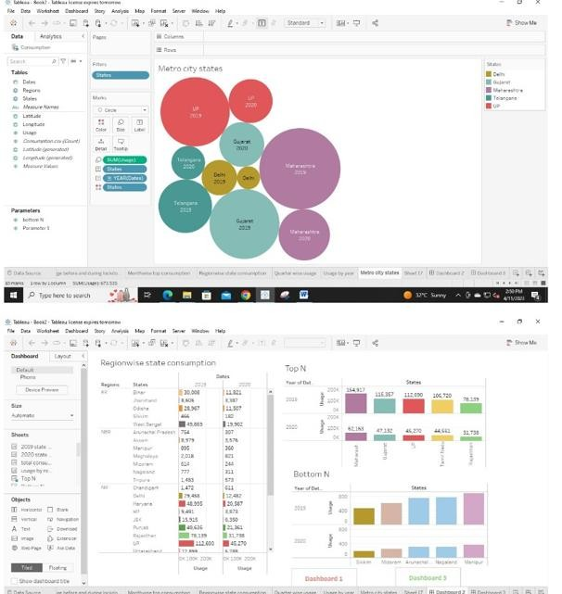
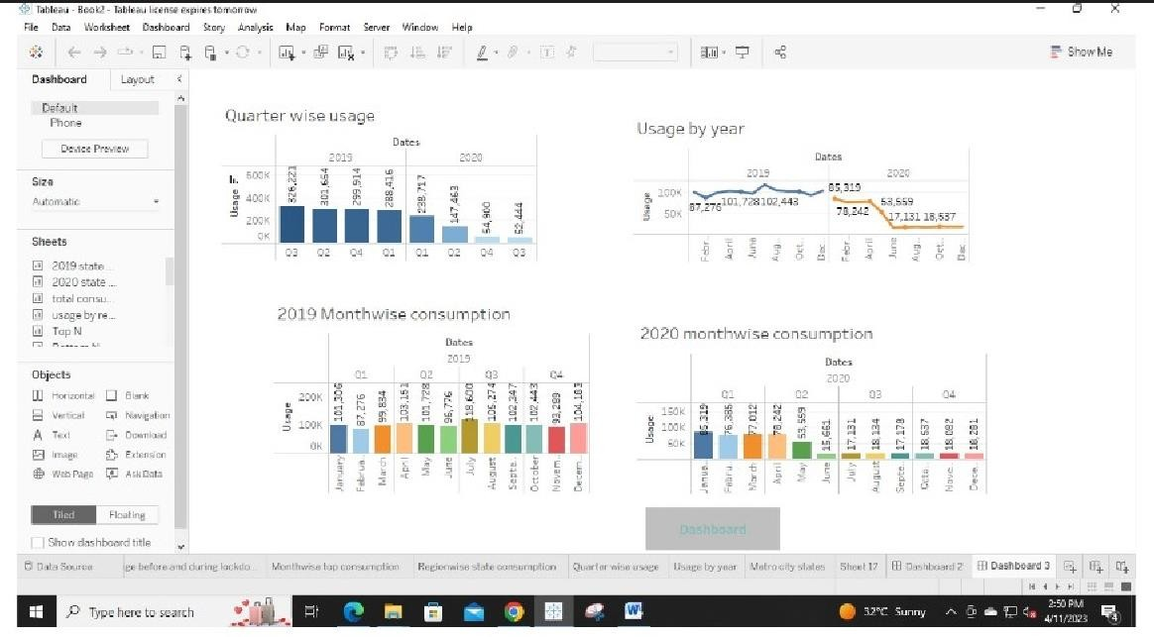

4. Advantages
- Convenience: Electricity allows us to power appliances and devices that make our lives more comfortable and convenient, such as refrigerators, air conditioners, and computers.
- Economic benefits: Electricity consumption contributes to economic growth by powering industries, creating job opportunities, and improving the standard of living.
- Safety: Electricity is a safer and more convenient form of energy compared to other sources, such as fossil fuels, which can be hazardous to handle and transport.
- Accessibility: Electricity can be distributed over long distances, making it accessible to people living in remote areas.
- Environmentally friendly: Electricity generated from renewable energy sources such as wind, solar, and hydropower, is environmentally friendly and sustainable, reducing greenhouse gas emissions and contributing to a cleaner environment.
- Flexibility: Electricity can be easily stored and transported, making it a flexible and versatile source of energy.

Disadvantages
While electricity consumption has many advantages, it also has several disadvantages, including:
- Environmental impact: The generation and consumption of electricity contribute to air and water pollution, deforestation, and climate change.
- Cost: The cost of electricity can be high, especially for low-income households and businesses, leading to affordability issues.
- Dependence on fossil fuels: Most electricity is still generated from fossil fuels, which are finite resources and have negative environmental impacts.
- Power outages: Power outages can occur due to natural disasters, equipment failures, and other factors, causing inconvenience and disruption to daily life.
- Safety hazards: Electricity can be hazardous if not handled or used properly, leading to electrical shocks, fires, and other accidents.
- Distribution challenges: Electricity transmission and distribution networks can be challenging to maintain and upgrade, especially in rural or remote areas.

Applications
Electricity consumption has numerous applications in various sectors, including:
- Residential: Electricity is used in homes for lighting, heating, cooling, cooking, and running appliances such as refrigerators, washing machines, and televisions.
- Commercial: Electricity is used by businesses, offices, and other commercial establishments for lighting, air conditioning, running machinery, and operating computers and other equipment.
- Industrial: Electricity is a vital component of the manufacturing sector, and it is used for powering assembly lines, running heavy machinery, and other industrial processes.
- Transportation: Electric vehicles rely on electricity to operate, and electric trains and other forms of public transportation use electricity to run.
- Agriculture: Electricity is used for irrigation, powering water pumps, and other agricultural activities.
- Communication and Technology: The use of electronic devices such as computers, mobile phones, and other communication equipment requires electricity.
- Healthcare: Electricity is essential for medical facilities, where it powers life-saving equipment such as ventilators, X-ray machines, and other medical devices.
Overall, the applications of electricity consumption are diverse and far-reaching, and it plays a critical role in supporting economic and social development in various sectors.

Conclusion
In conclusion, electricity consumption is a vital component of modern life and plays a crucial role in supporting economic and social development. It powers homes, businesses, industries, transportation, communication, and other essential sectors.
Future scope
The future scope for electricity consumption is vast and
exciting, with numerous opportunities for growth and innovation in various sectors. Here are some potential areas for development:
- Renewable energy: The use of renewable energy sources such as solar, wind, and hydropower is expected to increase significantly, providing a sustainable and environmentally friendly source of electricity.
- Smart grid technology: The use of smart grid technology can improve the efficiency and reliability of electricity distribution, allowing for better management of electricity consumption and reducing the risk of power outages.
- Electric vehicles: The adoption of electric vehicles is expected to increase rapidly, leading to increased demand for electricity for transportation and a reduction in fossil fuel consumption.
- Energy storage: The development of advanced energy storage technologies, such as batteries and fuel cells, can help to store excess electricity generated from renewable sources, making it available when needed.
- Microgrids: The use of microgrids, which are small-scale electricity generation and distribution systems, can provide reliable and sustainable electricity to remote and off-grid communities.

THANKING YOU…

